**Week 9 Lab**

**Exercise 2**

**8.)** 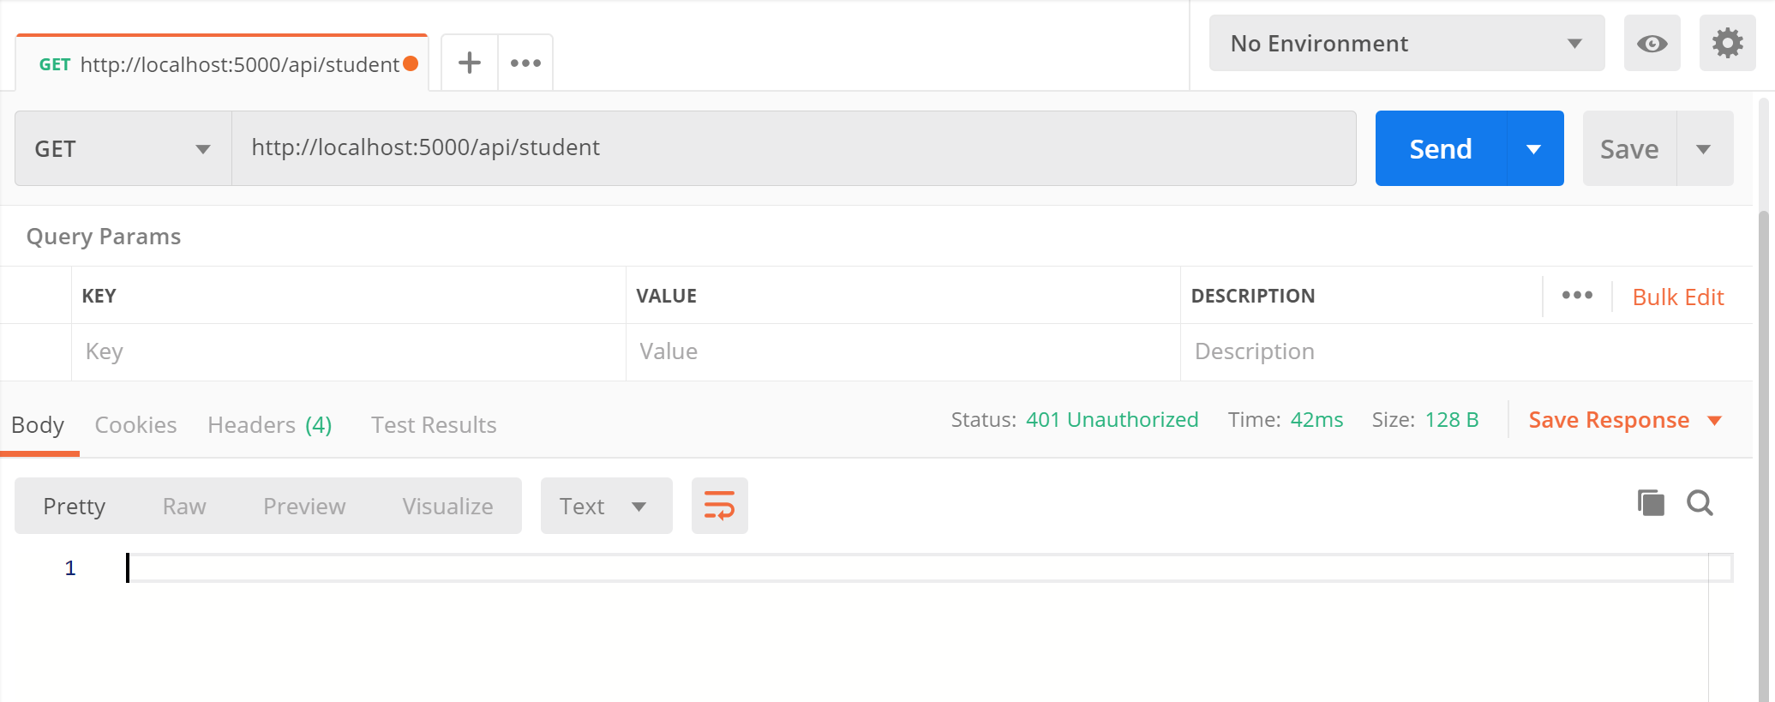

**9.)**

